CHEEKY NEWSLETTER
December 2025
Upcoming Christmas Holiday
The nursery will be closed from the 24th December for Christmas and New Year reopening on Monday the 5th January 2026. We wish everyone a lovely Christmas break.

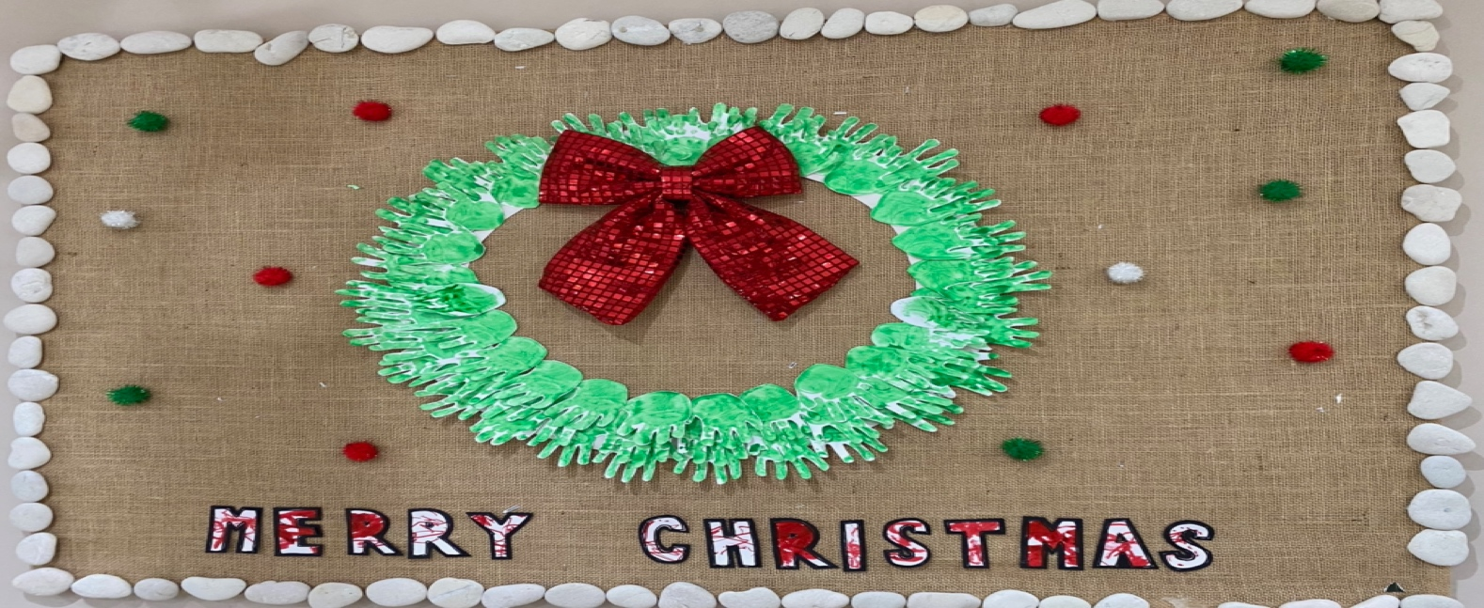
Welcome
A warm welcome to all our new children and families joining Cheeky Monkeys.

Winter Weather & Clothing
Please can nursery bags be taken home at the end of each week and returned with named and weather appropriate clothing for the colder weather including splash suits, hats, gloves and a coat. Please also check all wellies and slippers are the correct size for your child and take wellies/splash suits home to dry at the weekends. All children require a warm coat on their pegs daily please. Thank you.

Spare Clothing
Please ensure that if your child has borrowed Nursey spare clothing that is washed and returned as soon as possible.
Thank you.

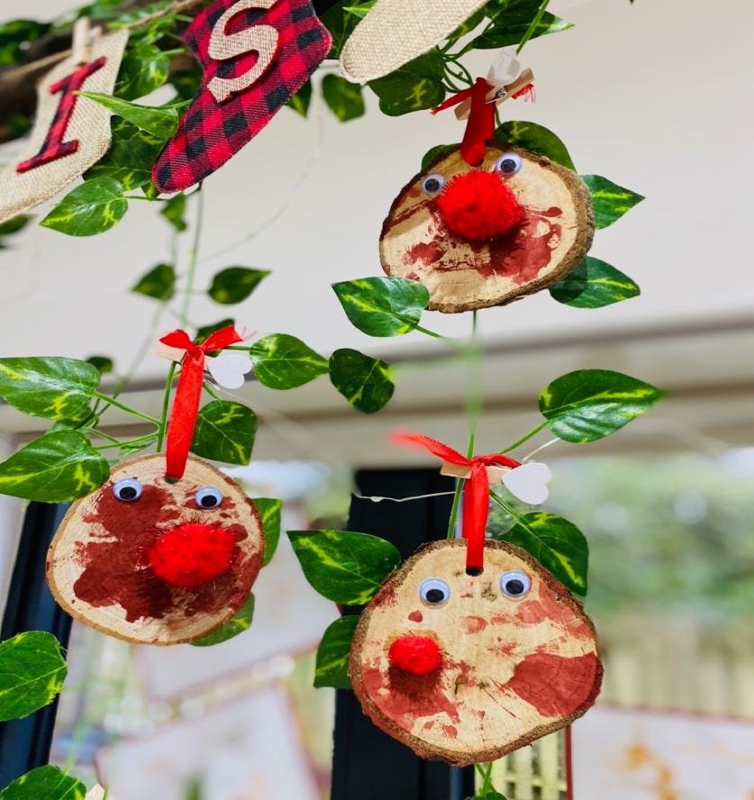
This month we are focusing on Winter and Christmas looking at the natural environment around us and changing seasons. We have also been looking at ‘Reggio’ inspired practice using both light and reflection including the use of projectors. Our new potter’s wheel has been used for the first time, which the children really enjoyed. We are still looking for any old telephones and laptops to help with this project.
DATES FOR THE DIARY
18th December Christmas Party with Santa. Party Clothes

